BRIARWOOD GOLF FELLOWSHIP OUTING
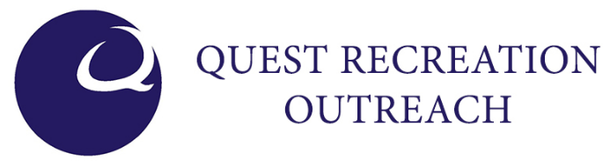
DATE/TIME: WEDNESDAY, APRIL 27th, 2022; 8:00 A.M. – 2:30 P.M.
8:30 A.M. Shotgun start with 1:30 P.M. Lunch
VENUE: BENT BROOK
PICK YOUR FORMAT:
4 PERSON SCRAMBLE (Minimum of 8 - 10 foursomes)
Following Drives, all 4 play each shot from the best position yielding a net score on each hole.
Each team must use at least 1 Drive from each team member during the round.

4 PERSON BEST BALL (Minimum of 8 – 10 foursomes)
Each player completes play and the best score for the hole yields the team’s net score (see below).
Cost per foursome: $300.00
Cost per individual: $80.00
Barbecue Lunch provided during awards presentations.
Awards:
1st, 2nd and 3rd Place for each format
Closest to Pin on all Par 3’s
Longest Drive
Most Accurate Drive

(Handicaps for each player in the BEST BALL competition will be determined by calculating over/under par scores on random holes and multiplying by 3, including: 4 par fours, 1 par 3 and 1 par 5.)

BRIARWOOD GOLF FELLOWSHIP OUTING

REGISTRATION
FOURSOME ($300) INDIVIDUAL ($80)
- ____________________________ ________________________________

- ____________________________

- ____________________________

- ____________________________

PREFERRED FORMAT (circle one) SCRAMBLE
BEST BALL

HOLE SPONSORSHIP: ($75) ___
INDIVIDUAL, COMPANY OR ORGANIZATION NAME FOR SIGN(S):
_____________________________________________________________
(LOGO CAN BE INCLUDED ON YOUR SIGN IF DESIRED – SUBMIT ARTWORK TO: sgathings@ofcworkscapes.com)

BREAKFAST SPONSORSHIP: ($200) ____
LUNCH SPONSORSHIP: ($350) ____
_____________________________________________________________
(LOGO CAN BE INCLUDED ON YOUR SIGN IF DESIRED – SUBMIT ARTWORK TO: sgathings@ofcworkscapes.com)

To Register please send this completed form to Quest@Briarwood.org
Or drop off in Quest office, G-100

